**POLYNOMIALS**

I. VOCABULARY:

Polynomials: comes from *~poly* (meaning many) and *~nomial* (meaning term) so it says

“many terms”

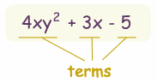

Example:

*A polynomial can have a Constant, variable, coefficient, and exponents

Constant: -5 Variable: x & y

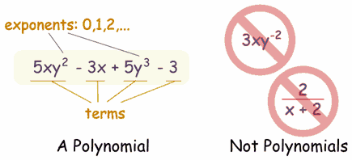Coefficient: 4 & 3 Exponent: 2

II. KINDS OF POLYNOMIALS:

monomial, binomial, trinomial

The "Standard Form" for writing down a polynomial is to put the terms with the highest degree first (like the "2" in x2 if there is one variable).

**Example: Put this in Standard Form:**

**3x2 - 7 + 4x3 + x6**

The highest degree is 6, so that goes first, then 3, 2 and then the constant last:

**x6** + 4**x3** + 3**x2** - 7

III. ADD, SUBTRACT, MULIPLY, DIVIDE

***1. ADDING:***

## *Like Terms

[Like Terms](http://www.mathsisfun.com/algebra/like-terms.html) are **terms** whose variables (and their [exponents](http://www.mathsisfun.com/exponent.html) such as the 2 in x2) are the same.

In other words, terms that are "like" each other.

Note: the **coefficients** (the numbers you multiply by, such as "5" in 5x) can be different.

Two Steps:

1. Place **like terms** together

2. Add the like terms

Example: Add     **2x2 + 6x + 5**     and     **3x2 - 2x - 1**

|  |  |  |  |  |  |
| --- | --- | --- | --- | --- | --- |
| Start with: | **2x2 + 6x + 5**     +     **3x2 - 2x - 1** | | | | |
|  |  |  |  |  |  |
| Place like terms together: | **2x2 + 3x2** | **+** | **6x - 2x** | **+** | **5 - 1** |
|  |  |  |  |  |  |
| Add the like terms: | **(2+3)x2** | **+** | **(6-2)x** | **+** | **(5-1)** |

= **5x2 + 4x + 4**

***2. SUBTRACTING:***

To subtract Polynomials, first **reverse the sign of each term** we are subtracting (in other words turn "+" into "-", and "-" into "+"), **then add** as usual.



*Note: After subtracting 2xy from 2xy we ended up with 0, so there is no need to mention the "xy" term any more.*

***3. MULTIPLYING:***

## 1) 1 term × 1 term   (monomial times monomial)

To multiply one term by another term, first multiply the **constants**, then multiply **each variable** together and combine the result, like this (press play):

Example: 

## 2) 1 term × 2 terms   (monomial times binomial)

Multiply the single term by each of the two terms, like this:

Example: 

## 3) 2 term × 1 terms   (binomial times monomial)

Multiply each of the two terms by the single term, like this:

Example: 

## 4) 2 terms × 2 terms (binomial times binomial)

|  |
| --- |
| Each of the **two terms** in the first binomial ... |
| ... is **multiplied by** ... |
| ... each of the **two terms** in the second binomial |

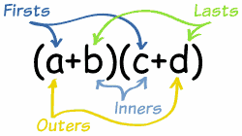 “FOIL”

FIRST, OUTER, INNER, LAST

Example: 

## 5) 2 terms × 3 terms (binomial times trinomial)

"FOIL" won't work here, because there are more terms now. But just remember:

Multiply each term in the first polynomial by each term in the second polynomial

## Like Terms

And always remember to add [**Like Terms**](http://www.mathsisfun.com/algebra/like-terms.html):

### Example: (x + 2y)(3x − 4y + 5)

### (x + 2y)(3x − 4y + 5)

### = 3x2 − 4xy + 5x + 6xy − 8y2 + 10y

### = 3x2 + 2xy + 5x − 8y2 + 10y

Note: **−4xy** and **6xy** are added because they are Like Terms.

Also note: **6yx** means the same thing as **6xy**

***4. DIVIDING:***

Sometimes it is easy to divide a polynomial by splitting it at the "+" and "-" signs

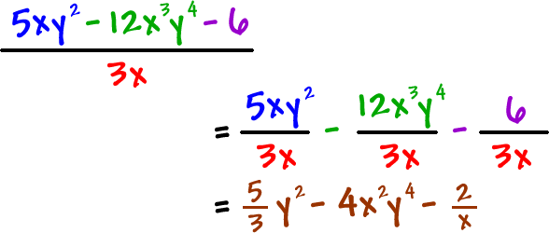Examples:

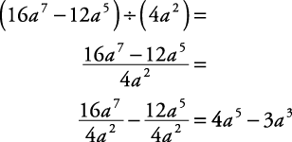

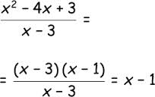Example: